24.34: a) For a spherical capacitor:
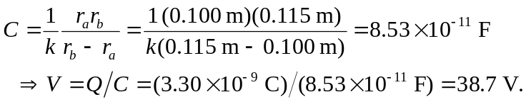
b) 